Trailway News August 2013

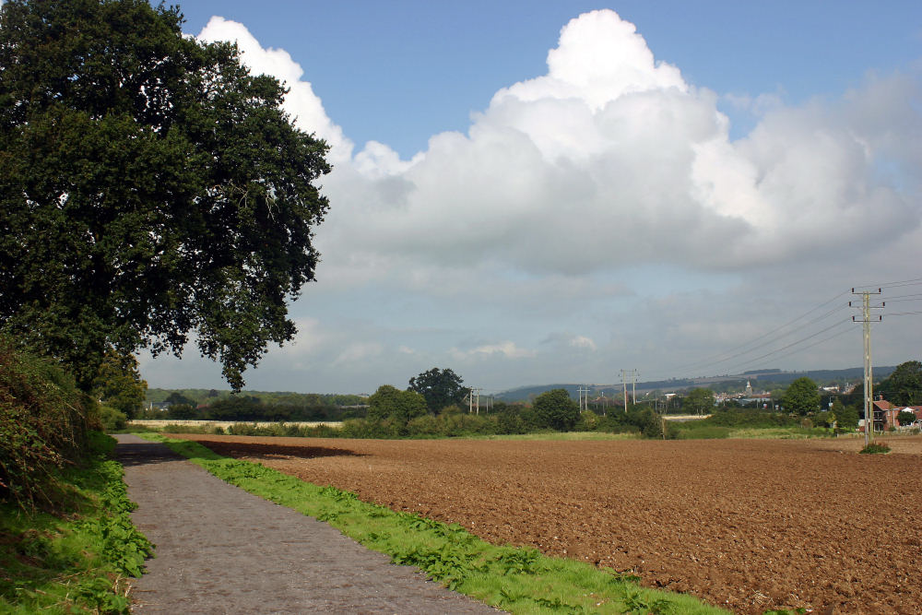
One of the possible sites for a bench donated by Blandford St. Mary Parish Council

August Walk, New Benches and the BHS award to Dorset County Council

The August walk is arranged for Spetisbury starting at 11.00am on 17th August from the School Car Park. It is a guided walk and is fairly short in distance but the guides have an interest in local flora and fauna so there will be plenty to see and hear about.
There is a limit to the number of walkers – 15 can be accommodated so if you want to come on the walk and bring a friend let me know and I shall ensure there are not more than the number allowed. The walk should take about an hour and a half so will be over before lunch. These walks are a good way to explore the countryside and our lovely areas in North Dorset please come if you can.

New Benches. The Trailway seems to attract benches. We have been offered two new benches. Adam Frampton of Hammoon is putting a bench in memory of his father on the Trailway between Hammoon and Fiddleford and the Ramblers have offered us a bench to go on the Trailway section in Stalbridge by the Nature reserve.
Both of these are very welcome because it means that people who may not be able to use the Trailway because of walking difficulties will have somewhere to rest.

The British Horse Society has given a Route Creation Award to Dorset County Council. The BHS magazine Tracks reported Dorset County Council have been presented with a route creation award for their role in the multi-user route for horse riders, walkers cyclists and mobility scooters on the disused Somerset and Dorset railway line. The path is three to four metres wide and has a hard wearing surface, suitable for all users.
Lesley Gasson

