Trailway News July 2013

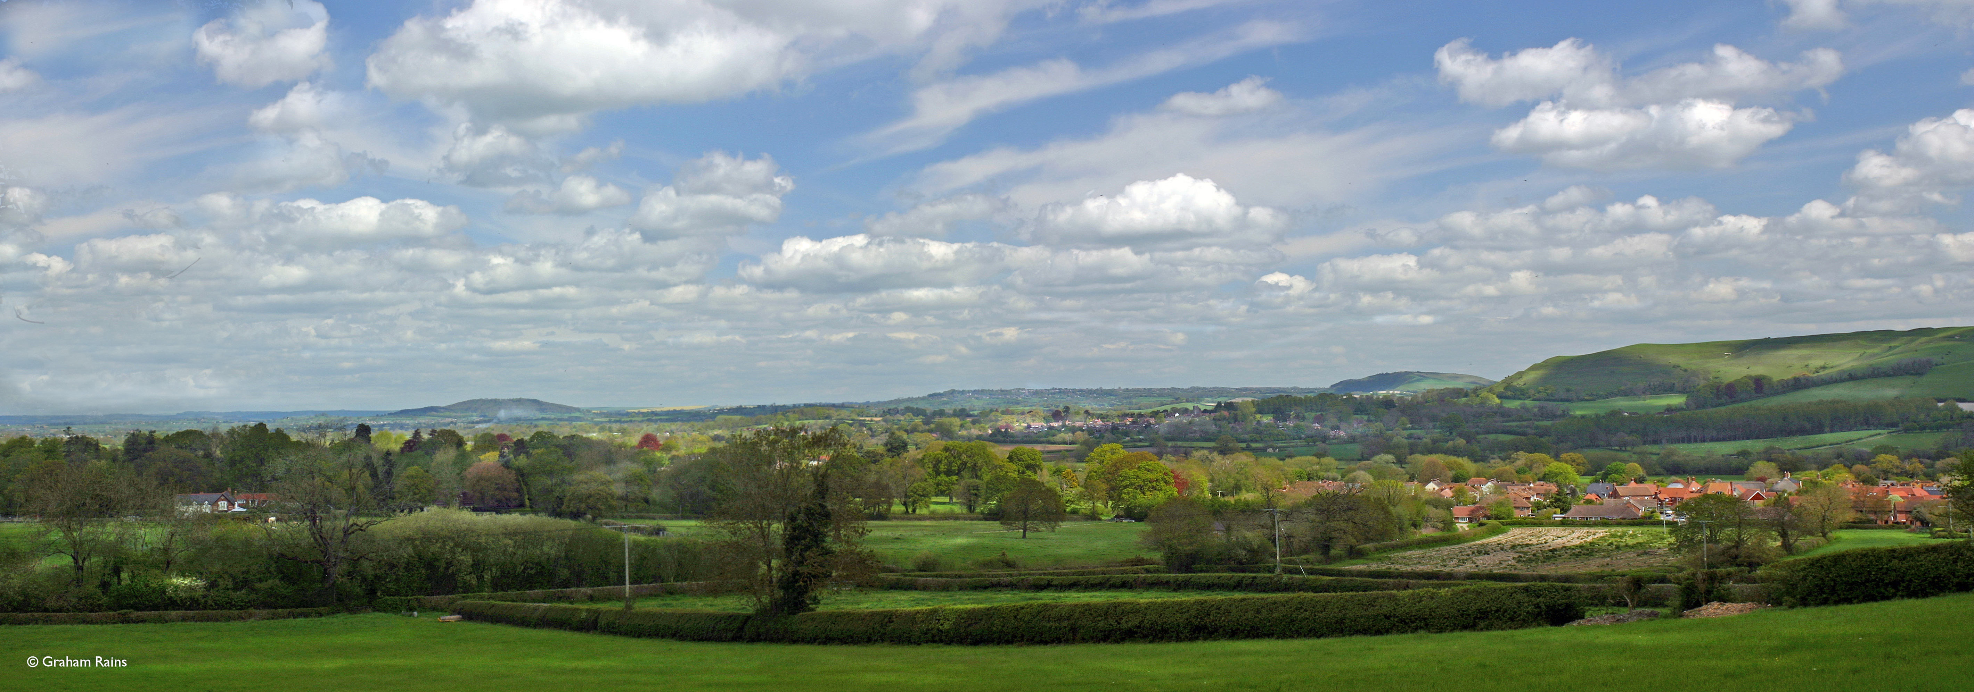
A view of Shillingstone from the steps near White Pit quarry
This is a short newsletter about Trailway walks, a new bench on the Trailway, Bank Holiday Monday at the Railway Arches and further developments.

Trailway walks
Our first walk organised from Sturminster Newton to Fiddleford Mill went well. We tended to part company at the Mill as some stayed on for a cup of tea and a cake at the Lavender Farm Open Day and some continued on the walk. A happy afternoon was had by all.

Shillingstone Old Ox start at 2.30pm on 28th July is our next walk.
There are three possibilities
i) If the weather is HOT we shall do a shortish flat walk in the shade. We shall start at the Old Ox go down the Trailway to Holloway Lane; follow the Wessex Ridgeway to the foot of Shillingstone Hill and the take the footpath around the bottom of the hill to the Quarry steps (view shown above) then back via Puzzle Drove to the village and the Old Ox.
ii) If the weather is cool we shall walk along the Trailway to Stourpaine; go round Hod Hill and back via Hod Drive to the Trailway. This is a much longer walk; it goes uphill therefore much better done on a cool day.
iii) If is it is raining all walks are cancelled for that day but we may find a later date for it.

A new Bench on the Trailway.
Blandford St. Mary village Council has generously donated a new bench to the Trailway to be sited on the Charlton Marshall side of the Trailway beyond Wards Drove where there is a view of the area. The Countryside Rangers will install it when it is delivered. This will be a welcome addition to our benches as there are very few on the southern side of Blandford.

Bank Holiday Monday Blandford Railway Arches
The Blandford Railway Arches Trust is having an event at the Railway Arches in the afternoon on Bank Holiday Monday. There will be an announcement about ideas for the Arches, Music and refreshments. It sounds like a pleasant place to spend an afternoon if you are in Blandford and want some entertainment.

Further Developments.
We wait to hear more about superfast Broadband using the Trailway but Defra have not been clear about their ideas.
Work is starting on extending the Trailway towards Stalbridge; a slow process but worth it.
Finally more and more people are enjoying the Trailway from all over Dorset.
Lesley Gasson

