Dorset County Council’s Mobile Library Service – consultation about proposed changes to the service
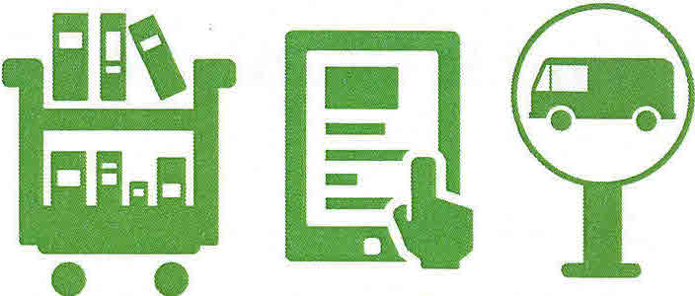

Introduction

Budget implications and good business practice has led us to reassess the service we offer and it will help us prioritise the delivery of a library service to residents who are unable to access library buildings.

Dorset County Council is facing unprecedented budget pressures and has to consider how it can best provide library services with a significantly reduced budget.

Currently there are four public library mobile vehicles serving stops across the county. From May 2016, this will change to three vehicles following re-timetabling of routes and the withdrawal of one vehicle. Another mobile, the Home Library Service mobile visits residential homes for older people and sheltered accommodation.

The proposal that we are consulting on is about more change to the mobile library service due to further budget reductions. The consultation is to help us better understand the impact of the proposed change on mobile library users.

What is the proposed change?
- To maintain the Home Library Service mobile to residential homes and sheltered accommodation
- To cease providing the public library mobile service and to ensure that people who are unable to access the service in other ways can continue to be provided with a library service.

Why are we reviewing the service?
- Use of the public library mobile service has been in decline over a number of years. This is partly due to changing needs and a growth in car ownership.
- The budget for the library service is reducing and the need to find savings means that change is required from a range of areas including the mobile library service.

Alternative ways of accessing the library service

Static libraries
There are 25 libraries managed by Dorset County Council and eight community managed libraries.

Home Library Service for individuals

The Home Library Service is delivered by Royal Voluntary Service (RVS) for people who are housebound and cannot get to a library. This bespoke service delivers books and other resources to customers at home free of charge at regular intervals. This service will continue and be expanded.
Please note that this is a different service to that provided by the Home Library Service mobile.

Good Neighbour (or family or friend)
If you are unable to visit the library and have a friend, family member or neighbour who would be willing to collect books on your behalf you can sign up under our “good neighbour” library membership category.
This will enable you to borrow the same number of items as a regular user although you will not be charged for overdue items. You will be sent a reminder if any items are overdue for return.
Online Services
You can access the library service online. You can download e-books and e- audio book services, which are free to use and can be accessed 24/7 via the Dorset for You website. You can also reserve books for collection from a library. For more information, visit www.dorsetforyou.com/libraries

Other

There is also the opportunity for community development work to enable some people to have access to library services through car sharing, befriending schemes etc

What happens next?

Once the consultation feedback has been analysed, the results will be presented to the People and Communities Overview and Scrutiny Committee at a future meeting in summer 2016 and then a decision will be taken by Cabinet.

Have your say

Your views are important so that we can better understand how the proposals will impact on you.

Please take the time to complete the survey so that we can understand the impact that the proposals may have. You can give your views online at www.dorsetforyou.com/mobile-library-consultation or return this form via the mobile library or any static library.

The consultation is open from 4 April to14 May 2016.

